# Evaluation Framework

## Development - Evaluation critireas

### Program quality metrics - Checklist

This software code quality guideline is a modified version of ISO 5055 best practices catering to our Agile Software Development Practices. For more information on what is ISO 5055 - please read here - [What Is ISO 5055? | Perforce](https://www.perforce.com/blog/sca/what-is-iso-5055). Please get in touch with you Lead / EM for clarifications on this.

|  |  |  |
| --- | --- | --- |
| SOFTWARE QUALITY CHARACTERISTIC | CODING PRACTICES UNIT LEVEL | ARCHITECTURAL PRACTICES SYSTEM LEVEL |
| **RELIABILITY (4)** | Protecting state in multi- threaded environments  Safe use of inheritance and polymorphism  Resource bounds management, Complex code  Managing allocated resources, Timeouts | Adhere to Multi-layer design compliance.  Manage data integrity and consistency  Handle Exception through transactions  Adhere to Class architecture compliance |
| **PERFORMANCE EFFICIENCY (5)** | Compliance with Object- Oriented best practices  Compliance with SQL best practices  Handling expensive  computations in loops | Appropriate level of interactions with expensive or remote resources  Handle Data access performance and data  management |
|  | Handling static connections versus connection pools | Handle Memory, network and  disk space management |
|  | Compliance with garbage collection best practices | Centralized handling of client  requests |
|  |  | Use of middle tier components vs. procedures/DB functions |
| **SECURITY (6 - 5)** | Avoid use of hard-coded credentials | Do Input validation  Secure against SQL injection  Secure against Cross-site  scripting  Use vetted libraries or frameworks.  Adhere to Secure architecture design compliance |
|  | Handle Buffer overflows |
|  | Avoid missing initialization  issues. |
|  | Handle validation of array  index |
|  | Avoid improper locking. |
|  | Avoid uncontrolled format strings |
| **MAINTAINABILITY (6 - 4)** | Avoid unstructured and duplicated code | Avoid Duplicated business logic |
|  | Handle high cyclomatic complexity.  Handle controlled level of dynamic coding  Avoid Over-parameterization of methods | Adhere to Strict hierarchy of calling between architectural layers  Avoid Excessive horizontal layers |

|  |  |  |
| --- | --- | --- |
|  | Avoid hard coding of literals  Avoid Excessive component sizes | Avoid Excessive multi-tier fan- in/fan-out |

## Evaluation Process Guide

Following is a step-by-step process how an individual member’s performance evaluation should progress.

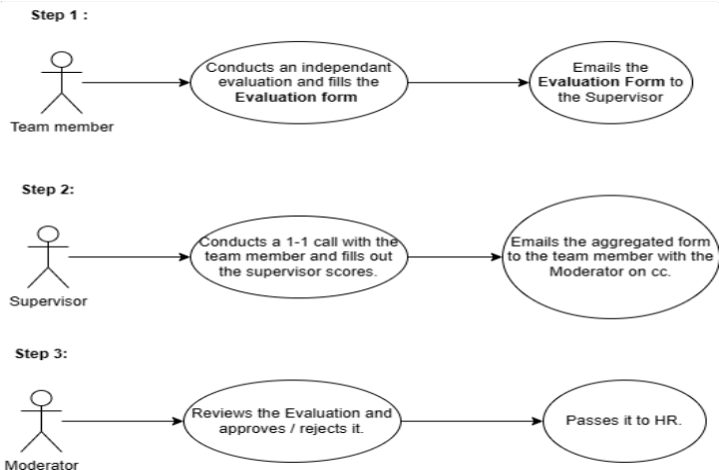

## Evaluation Form - Developer

Form link - Evaluation form - Developer

## Performance Improvement Plan

Here is the process.

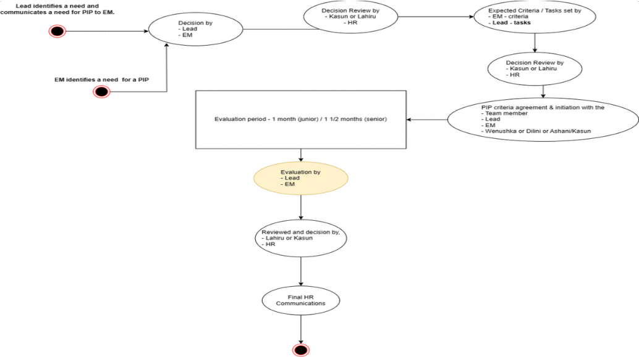

Here is the evaluation form - Performance Evaluation Form

## BA - Evaluation criteria

If any KPI output has a % value, the said value will be associated with the evaluation score ranging from 1-5

|  |  |  |
| --- | --- | --- |
| **Percentage value** | **Score** | **Description** |
| 0-20% | 1 | Never meets expectations. |
| 21-40% | 2 | Sometimes meets expectations. |
| 41%-60% | 3 | Meets expectations. |
| 61-80% | 4 | Sometimes exceeds expectations. |
| 81-100% | 5 | Always exceeds expectations. |

BA will be evaluated in 4 segments namely technical skills, Teamwork, Communication, and Delivery. The KPI(s) under each segment will assist the RO to evaluate the BA.

Technical Skills

**KPI 1: Writing both functional and non-functional user stories.**

*Well defined user story:*

 *User story format clearly followed (User story table/ As a, So that, I can/ etc.). * *Clear acceptance criteria with equal to or less than 8 lines per user story.*

 *Story point estimation per user story should be equal to or less than 8.*

 *Including diagrams/ wireframes or any other additional artifacts to support development.*

*Substandard user story:*

· *User stories which are not covered under the 'Well defined user story' will be considered as substandard user story.*

KPI 2: Use of elicitation or requirement gathering techniques.

When eliciting the requirement, the BA must follow at least 5 elicitation techniques altogether in all projects.

Examples

 Brainstorming.

 Document Analysis  Focus Group

 Interface Analysis  Interviews

 Observation  Prototyping  Workshops

|  |  |
| --- | --- |
| **Score** | **Description** |
| 1 | Use of 1 technique |
| 2 | Use of 2 techniques |
| 3 | Use of 3 techniques |
| 4 | Use of 4 techniques |
| 5 | Use of 5 techniques |

KPI 3: Requirement Analysis and Solution Design.

|  |  |
| --- | --- |
| **Score** | **Description** |
| 1 | No participation in solution design discussions |
| 2 | Occasional participation in solution design discussions |
| 3 | Attending of all solution design discussions and providing inputs |
| 4 | · Actively participating and providing inputs in solution design discussions  Providing solution diagrams/wireframes to support design discussion |
| 5 | * Inclusion of points discussed under score 4 and the below. * Solution proposed has,   BA drafted wireframes (With all functions covered) CX (Customer journey, UI component placement,  Policies etc) is clearly explained and defined.  Followed with cross-functional teams for clarifications and clearance |

Note: *Score 1-3* assesses the BA's attendance to solution design discussions.

*Score 4* assesses the BA's attendance along with proactive action where the BA drafts a high-level solution design before attending the design discussion.

*Score 5* assesses the BA's attendance along with proactive action where the BA drafts a complete solution design which consists of the entire user journey inclusive of wireframes/ flows/ policies etc.

**KPI 4: Documentation Skills.**

|  |  |
| --- | --- |
| **Score** | **Description** |
| 1 | BA is not aware of available documentation guidelines and templates |
| 2 | BA is aware of available documentation guidelines and templates but not applied within the project(s) |
| 3 | * Has basic knowledge of word/ PowerPoint/ excel.   Creation of documents Creation of presentations  Creation of spreadsheets (e.g., For cost analysis)   * BA is aware and has followed the predefined templates within the project.   User story format User guide format  Hand over document format etc.   * BA documentation guidelines compliance is at least 80% |
| 4 | * Inclusion of points discussed under score 3 and the below, * BA documentation guidelines compliance is at least 90% * Conducted trainings/ awareness on documentation tools and techniques used to any member within Company |
| 5 | * Inclusion of points discussed under score 4 and the below. * BA documentation guidelines compliance is more 90% * Conducted trainings/ awareness on documentation tools and techniques used to any member within Company |

|  |  |
| --- | --- |
|  | · Has suggested improvements to be incorporated into the documentation guidelines & templates which gets implemented in BA practice |

**KPI 5: Adherence to the BA Practices.**

|  |  |
| --- | --- |
| **Score** | **Description** |
| 1 | BA is not aware of available BA practices |
| 2 | BA is aware of available BA practices but does not apply within the project(s) |
| 3 | * Sharing daily work progress update [At least thrice a week] at the daily standup's and updating BA sync up board. * Participating in weekly BA sync up/trainings. * Completing assigned training materials * Conducting sessions for BA sync-ups [At least 2 per quarter] |
| 4 | · Inclusion of points discussed under score 3 and the below.  Proposing new practices/ methods/ techniques which get approved for implementation [Idea generation and management approval. Idea to be submitted as a document/ via email] |
| 5 | * Inclusion of points discussed under score 4 and the below. * Implementing the new proposed practices/ methods/ techniques [Total solution implementation inclusive of Process flow diagrams/ Confluence page for process definition/ Trainings to peers etc ] |

**Teamwork**

**KPI 6: Participation for sprint related ceremonies and activities (%).**

**Communication**

**KPI 7: Clear and concise client communication.**

We will be sharing a questionnaire with the client as well as with the team lead/ architect to evaluate the communication skill of the BA who is assigned to the project.

***Questionnaire attached under appendix 1.***

|  |  |
| --- | --- |
| **Score** | **Description** |

|  |  |
| --- | --- |
| 1 | Avg score of client feedback and team lead/architect feedback on BA communication on quarterly basis is 1 |
| 2 | Avg score of client feedback and team lead/architect feedback on BA communication on quarterly basis is 2 |
| 3 | Avg score of client feedback and team lead/architect feedback on BA communication on quarterly basis is 3 |
| 4 | Avg score of client feedback and team lead/architect feedback on BA communication on quarterly basis is 4 |
| 5 | Avg score of client feedback and team lead/architect feedback on BA communication on quarterly basis is 5 |

We will be only considering the floor value of the avg feedback score.

Example: If the total score is 54 and there are 12 questions. Then avg score = (54/12) = 4.5 Then the final score would be considered as 4.

**Delivery**

**KPI 8: Percentage of on-time delivery of pre-sales activities (project scoping etc.).**

**KPI 9: Percentage of on-time delivery of project documentation (Handover document/ User manual etc.). Appendix 1: Communication Feedback form**

|  |  |  |
| --- | --- | --- |
| **BA Name:** | | |
| **Project:** | | |
| **Filled by:** | | |
| **Date:** | | |
| **Questionnaire** | | |
| **No** | **Question** | **Responses** |
| 1 | On a scale of 1 to 5 (1 being lowest, 5 being high), how would you rate the Business Analyst's ability to articulate complex ideas clearly and concisely? | 1. Poor 2. Fair 3. Good 4. Very Good 5. Excellent |
| 2 | How effectively does the Business Analyst tailor their communication style to suit the audience (e.g., technical teams, non-technical stakeholders, executives)? | 1. Not Effective 2. Somewhat Effective 3. Moderately Effective 4. Very Effective |

|  |  |  |
| --- | --- | --- |
|  |  | 5 Extremely Effective |
| 3 | To what extent does the Business Analyst demonstrate active listening skills during meetings and discussions? | 1. Rarely 2. Occasionally 3. Sometimes 4. Often 5. Always |
| 4 | Rate the Business Analyst's proficiency in writing clear and comprehensive documentation (e.g., requirements, user stories). | 1. Poor 2. Fair 3. Good 4. Very Good 5. Excellent |
| 5 | How well does the Business Analyst use visual aids (charts, graphs, diagrams) to enhance written communication? | 1. Not at all 2. Occasionally 3. Sometimes 4. Often 5. Always |
| 6 | Does the Business Analyst effectively communicate complex technical concepts to non- technical stakeholders in written documents? | 1. Rarely 2. Occasionally 3. Sometimes 4. Often 5. Always |
| 7 | How well does the Business Analyst facilitate and lead discussions in meetings, ensuring all voices are heard? | 1. Poorly 2. Fairly 3. Well 4. Very Well 5. Exceptionally Well |
| 8 | Rate the Business Analyst's ability to handle questions and challenges during presentations or discussions. | 1. Weak 2. Average 3. Above Average 4. Strong 5. Outstanding |
| 9 | To what extent does the Business Analyst encourage collaboration and open communication within the project team? | 1. Rarely 2. Occasionally 3. Sometimes 4. Often |

|  |  |  |
| --- | --- | --- |
|  |  | 5 Always |
| 10 | How well does the Business Analyst establish and maintain effective communication channels with stakeholders? | 1. Ineffective 2. Somewhat Effective 3. Moderately Effective 4. Very Effective 5. Extremely Effective |
| 11 | Rate the Business Analyst's ability to manage and resolve conflicts that arise during stakeholder interactions. | 1. Poor 2. Fair 3. Good 4. Very Good 5. Excellent |
| 12 | Does the Business Analyst provide timely and clear updates to stakeholders regarding project progress and changes? | 1. Rarely 2. Occasionally 3. Sometimes 4. Often 5. Always |

## BMS Team KPIs for 23/24

1. **Preparation:**

 **Team Goals:**

 **Review Previous KPIs:**.

1. **Purpose:**

 is to enhance analysis efficiency, accuracy, and overall contribution to the brave BMS objectives.

Context:

 **Brave Goals:**.

 **Team Goals:** Discuss a specific project, such as optimizing a data, and how it ties into broader team goals.

Interactive Discussion:  Common KPIs:

 Metric 1:

 Metric 2:

 Individual KPIs:

 Metric 1:

 Metric 2:

Prioritization and Consensus:  Voting or Ranking:

 **Consensus Building:** Encourage team members to discuss the importance of each metric and work towards a shared understanding.

SMART Criteria:

 **Specific, Measurable, Achievable, Relevant, Time-Bound:**

 Specific: "Increase data accuracy by 10%."

 Measurable: "Complete 95% of projects within the given timeline."

 Achievable: Ensure that the team has the necessary resources to meet the targets.  Relevant: Align the KPIs with the overall goal of improving data analysis efficiency.  Time-Bound: "Achieve the accuracy target within the next quarter."

Documentation:

 **Document Decisions:** Create a document summarizing the chosen KPIs, including the rationale and any specific targets (HR/Lead).

 **Share Documentation:** Distribute this document among team members (HR).

Feedback and Adjustments:

 **Open Door for Feedback:** Encourage team members to provide feedback on the selected KPIs and be open to making adjustments.

 **Iterative Process:** If a KPI is not proving effective, be willing to revisit and revise it.

1. **Communication of KPIs:** Send a team-wide email detailing the finalized KPIs, explaining their significance, and reiterating how they contribute to the team and organizational goals.

Regular Review:

 **Scheduled Check-Ins:** Plan monthly or quarterly check-ins to review progress on each KPI, discuss challenges, and make any necessary adjustments.